PREPARATION OF THE PAPER FOR MENDEL JOURNAL PUBLICATION (ALL CAPS, LM Sans 14PT, LEFT JUSTIFY)
First Author^{1,} (Name Surname), Second Author², …
(12pt LM Sans 10, left justify)
¹Department, University, Country (9pt cmss12, left justify)
²Department, R&D Company, Country
correspondingauthor@xxx.xx, otherauthors@xxx.xx (8pt cmss12, left justify)
Abstract
This is a sample of the format of your full paper. Use Word for Windows (Mi-crosoft) (or equivalent Word Processor with exactly the same “printing results”) or LATEX by using our template. Please do not number the pages! Use single space. Use 10pt, LM Sans/LM Roman for MS Word. If you use MS Word, your paper will be rewritten into LATEX at our end. For text in abstract and keywords use Italics. Leave one blank line after the Abstract.
Keywords: Write your keywords (6–10 words). Comma separated, ending with a period. Leave double blank line after your keywords. | Received: 06 November 2017  Accepted: 05 March 2028  Published: 13 April 2039

1 Introduction
As you ‘‘...’’ can see for the title of the paper you must use 14pt, Capital, Centred, Bold. Please do not number the pages! Leave one blank line (14pt) and then type Authors' Names etc., see above.
Paper text should be typed in 10pt LM Roman for MS Word or equivalent Word Processors and justify to block. The heading of each section should be printed in small, 12pt, left justified, bold, serif. You must use the Arabic numbers 1, 2, 3, for the sections numbering and not the Roman numbers (I, II, III, ). Please, follow the paragraph indentation that is used in this template.
2 Problem Formulation (Equations and Variables)
Please, leave two blank lines between successive sections as here (see Section 1 to Section 2). Please note that the first line of text that follows a heading is not indented, whereas the first lines of all subsequent paragraphs are. Further on please use the LaTeX or MS Word (equivalent) automatism for all your cross-references and citations.
Mathematical Equations must be centred and numbered as follows: (1), (2), ..., (99) and not (1.1), (1.2), …, (2.1), (2.2), depending on your various Sections.

 | $$z^{EO}=\min_{e,g(ξ)}E(F(ξ,e,g(ξ))$$ | (1)
 | $$a_{min}≤a≤a_{max}$$ | (2)

2.1 Important Subsection
Wen including a subsection you must use, for its heading, small letters, 10pt, left justified, bold as here. Use the standard equation environment to typeset your equations, however, for multiline equations we recommend using the eqnarray environment (LATEX users)

Definition. This is a definition text. This is a definition text.

Theorem. This is a theorem content. Theorem text goes here.

Proof. Let this be a proof text. Then the following text proves the theorem. □
3 Problem Solution
Figures and Tables should be numbered as follows: Fig. 1, Fig. 2, … etc. (see Fig. 1), Table 1, Table 2, ..., etc. (see Table 1). The figures are expected to be printed in colour (the text and tables strictly in black), but authors are strongly recommended to test the readability of the figures in gray shades to be on the safe side. Figure quality must be appropriate for the print and labels must be readable, our suggestion is resolution 300dpi and vector format is preferred. The screen capture bitmap in the case of graphs or diagrams is considered as highly inappropriate. Figure caption must be placed below the figure and table caption must be placed above the table. If the caption is single line, it should be centered. If the caption spans more thanone line, it should be left justified.

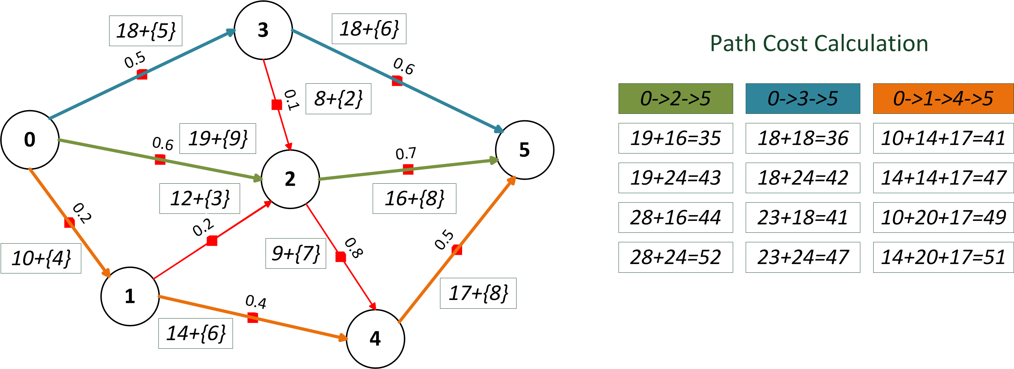

Figure 1: Please write your figure caption here (multiple lines). If the caption spans multiple lines, please use left justification. If the caption is single line, it should be centered.
Table 1: Please write your table caption here (if single line, then centered).
Parameter | Value | GATE implementation
GA test suite | F₆, 5 optimized variables | funName: ‘F6’, nParam: 5, ...
GAHC | 10 HCA kernels of size 5 bits | mutationHC(GA,’HC12’,10,’rand’,5)

If your paper deviates significantly from these specifications, our Mendel publishing house may not be able to include your paper in the Proceedings. If you cite references in the text, type the corresponding number in square brackets as shown in the following two sentences. Please, follow the ACM citation style. As an example, look at the style of the following citations: [1], [3], [4], [6], [2], [5]. Combined citations like [3, 6] may have special appearance.
4 Conclusion
Please, follow our instructions faithfully; otherwise you have to resubmit your full paper. This will enable us to maintain uniformity in the conference proceedings. The better you look, the better we all look. We also encourage you to add the references to relevant articles from previous MENDEL publications, it would be helpful for the publication as such and most importantly for the authors. Thank you for your cooperation and contribution.

Acknowledgement: On this place you can return thanks for the support. Use 10pt LM Roman.
References
- CPLEX, 2020. https://www.ibm.com/support/ knowledgecenter/en/SSSA5P12.9.0/.
- Davoine, T., Hammer, P., and Vizvari, B. A heuristic for boolean optimization problems. Journal of Heuristics 9(2003), 229–247.
- Dongarra, J. Performance of various computers using standard linear equations software. Technical Report CS-89-85, 2010.
- Du, D., Gu, J., and Pardalos, P., Eds. Satisfiability Problem: Theory and Applications, vol. 35 of DIMACS Series in Discrete Mathematics and Theoretical Computer Science. 1997.
- Glover, F. Adaptive Memory Projection Methods for Integer Programming. Springer US, Boston, MA, 2005, pp. 425–440.
- Linderoth, J., and Lodi, A. MILP software. In Wiley Encyclopedia of Operations Research and Management Science, J. Cochran, L. C. Jr., P. Keskinocak, J. Kharoufeh, and J. Smith, Eds. Wiley, 2011.

